Original Contribution

Comparative Evaluation of Two Obstetrical/Gynecology Resident “Boot Camps” of Different Lengths: Equivalent Practice Skills Confidence and Knowledge Levels

Jeffrey D. Postlewaite, DO, FACOOG֎, David Boes, DO, FACOOG, Salvatore Finazzo

Keywords: knowledge improvements, practice confidence, ob/gyn, resident boot camps

Asian Journal of Applied Science and Engineering

Vol. 10, Issue 1, 2021 [Pages 1-5]

Since the earlier time of master-apprentice type GME relationships, more residency program educators have developed various forms of boot camps to ease incoming learners into their new specialty roles as first-year residents. Such boot camps have ranged from informal informational sessions with faculty using simulation activities, to more formal workshops entailing pre- and post-event skills assessments with simulation exercises, formative feedback and debriefing sessions. The purpose of this pilot project was to examine for relative pre- and post-boot camp changes in Obstetrics/Gynecology (OB/GYN) practice skills confidence and knowledge levels in two consecutive cohorts (2014 and 2015) of first-year residents. Boot camps were of two different lengths: a five-day 2014 camp (n = 32 residents) and shortened three-day 2015 boot camp (n = 29 residents). Respondents from both boot camp cohorts were invited to complete the same 25-item OB/GYN practice skills confidence and knowledge survey. The first three authors developed this survey prior to the initial boot camp (2014). Revisions/adjustments were then made to content after the 2014 to pare down from the initial five days’ worth of content for the 2014 boot camp to three days for the 2015 boot camp. Each of 45 sample resident respondents who provided complete pre-and post-boot camp data demonstrated improvements in self-rated practice confidence and knowledge levels. Mean per resident pre-post-boot camp survey rating levels for individual items in the shorter 2015 boot camp cohort increased by 1.096 (SD = 0.5487), over a two-fold increase for most individual items in the 2014 residents. Mean cohort differences represented a nonsignificant equivalent increase in pre-post practice confidence and knowledge levels for individual ratings items between the 2014 and 2015 cohorts (p = 0.241).

INTRODUCTION

Throughout their undergraduate and postgraduate medical education as learners, most incoming resident physicians face a series of transitions that can be stressful, sometimes causing them to question the adequacy of their clinical skills as they enter graduate medical education (GME) training. The major transition entailed from completing a medical school program to starting a specialty residency program may cause many new residents to experience uncertainty or anxiety concerning their preparation to enter clinical practice.

Purpose of Analyses

The purpose of these exploratory descriptive analyses was to examine for relative pre and post-boot camp changes in OB/GYN practice skills confidence and knowledge ratings in two cohorts of first-year OB/GYN residents post completion of boot camps of two different lengths: either a five-day boot camp (July, 2014) or a shortened three-day boot camp (July, 2015).

METHODS

The first 2014 boot camp was established by the first four authors (JDP, DB, SF, CC) to run for five consecutive days for first-year incoming residents from one of 13 OB/GYN Osteopathic Residencies in Michigan. The number of first-year residents in each residency program ranged between two and four, and the SCS provided a mechanism (website calendar downloadable pdf's) to share OB/GYN pre-boot camp educational resources.

The 2014 boot camp was structured to encompass an introduction to technical OB/GYN practice skills and knowledge content to help residents develop confidence in the transition from medical school to residency. Because our incoming resident learners come from around the country, it also allowed the residents to self-assess how confident they felt in their OB/GYN practice skills and knowledge compared to their colleagues from different medical school backgrounds.

This 2014 five-day boot camp encompassed didactic presentations, various knot tying skills, episiotomy/ perineal laceration repair, a variety of obstetrical skills (with a full day in the campus-based simulation center), OB/GYN triage cases, and quality and safety in the hospital. There was intentional repetition with some of the planned skills training to encourage retention. Fetal heart rate (FHR) interpretation was also a component of this boot camp. In 2015, the authors had decided to consolidate most of the same basic content into a three-day boot camp. Participation in both boot camps was encouraged but not mandatory.

Respondents from both the 2014 and 2015 boot camp cohorts were invited to complete the same 25-item OB/GYN practice skills confidence and knowledge survey that had been developed by the first three authors (JDP, DB, SF) before the first 2014 boot camp. (Appendix 1) The survey items each used a 1-5 Likert-type scale ranging from "Strongly Disagree" to "Strongly Agree" with an open-ended "comments" item at the end of the survey for respondents to enter any comments and/or suggestions for future boot camps.

The de-identified pre- and post-boot camp survey data from both OB/GYN cohorts were entered by the analyst author (WDC) into an S.P.S.S. version 22 data set for comparative descriptive analyses.

RESULTS

Complete pre- and post-boot camp OB/GYN practice skills confidence and knowledge ratings data were obtained from a total of 45 resident respondents, 33 from the 2014 boot camp and an additional 12 respondents from the 2015 boot camp. Quantitative survey item data required only a minor amount of cleaning. A total of 28 open-ended qualitative comments or suggestions written in by residents were also entered into word processing software.

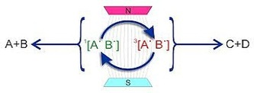
Figure 1: Environmental solution

Since the earlier time of predominant master-apprentice type GME relationships, more residency program educators have developed various forms of boot camps to ease incoming resident learners into.

Outcomes

For over 25 years, the Statewide Campus System14 (SCS) in the Michigan State University College of Osteopathic Medicine has coordinated the educational offerings for resident physicians and faculty across the state. The SCS currently serves over 190 community-based residency programs in 37 affiliated healthcare systems. In 2014, the SCS-affiliated clinician authors of this paper (JDP, DB, SF) initiated a five-day Obstetrics & Gynecology (OB/ GYN) skills and competency boot camp in an effort to better prepare a sample of 32 first-year resident learners from 13 osteopathic-oriented Michigan programs.

Table 1: Table Title – A brief descriptive title of the table

Note: List all abbreviations & full terms

Although the feedback from the first 2014 boot camp participants was positive, the OB/GYN authors (JDP, DB, SF) felt that it may be prudent to shorten the 2015 boot camp based on the logistical (e.g., resident and faculty schedules, venue costs, etc.) complexities of delivering the longer event for learners from across the state. After reviewing the boot camp content, it was determined they could cover the same content in three days specifically by minimizing content duplication.

DISCUSSION

During recent years, a wide variety of sizes, types, and duration of boot camps have evolved for different types of first-year physician residents.1,3,6,10 The boot camps to date have lasted from one day to seven weeks, with a wide variation in number of hours per day, and/or days per week. Nevertheless, most reports suggest these comprise an effective tool to improve practice skills confidence and knowledge, with positive feedback from learners.11 The authors' intentions for these boot camps were to develop an effective tool for transition from medical school to an OB/GYN residency. This was considered particularly important given the typical time constraints between graduation and starting residency as earlier described.

Qualitative Resident Comments

A total of 28 (62.2% of complete data sample) respondents offered specific comments regarding what components of their respective boot camp they most appreciated or could be improved.

Strengths
- Great hands on learning opportunities.
- Suturing practice every day was helpful.
- Made me less apprehensive going into intern year.
- Fetal monitoring course was awesome.
- Great review of instruments.
- Laid back lectures helped information get across.

Areas to Improve
- Need more instruction on fetal heart rate monitoring steps.
- A few very repetitive lectures (Labor & Delivery).
- NEED to go over suturing in a lecture before going into hands on.
- Could be condensed to 3-4 days without all of the repetitive lectures.
- More time for Neonatal Resusciation Program (NRP).

The overall goal of these analyses was to determine if the authors could cover the same basic content in three days and achieve equivalent learner practice skills confidence outcomes. In future boot camps, we intend to utilize additional assessment tools (pre- and post-boot camp), such as the Association of Professors of Gynecology and Obstetrics (APGO) Preparation for Ob-Gyn Residency Knowledge Assessment Tool (PrepForRes) exam,16 to more rigorously measure effectiveness of learning and retention.

Study Limitations

These results should be reviewed within the context of several major limitations. Obviously, two small convenience samples of OB/GYN residents from Michigan residency programs may certainly limit the generalizability of these findings to other parts of the country. In addition, the considerably smaller size of the 2015 respondent cohort limited our ability to use inferential statistical procedures to compare learner practice skills confidence and knowledge differences between the two boot camp cohorts.

Figure 2: Historical Solution

This was also the first two times that the authors had used this untested 25-item survey instrument. The manner in which the 2014 and 2015 boot camps may have differed in other unmeasured ways could also have skewed our measured cohort differences. It would also have been ideal to follow these participating OB/GYN residents longitudinally to more systematically evaluate the actual total impact of the boot camp through the perspectives of the residents and/or their residency program faculty.

CONCLUSIONS

There appears to be a growing consensus that there is benefit to providing a boot camp format for transition from medical school to residency.5,6,11 In addition, the Level 1 ACGME Milestones now provide a more focused set of expectations of what an incoming first-year OB/GYN resident should know or be able to perform.17 As various boot camp formats evolve, it will be important to measure the perceived value of these events by varied GME learners in addition to measuring pre- and post-training practice skill confidence levels.

Based on these initial results, the authors have determined that it may be possible to adjust the boot camp described here from five days to three and still achieve comparable practice skill confidence and knowledge outcomes while delivering the same basic OB/GYN content. While there has been a perceived benefit of providing a longer, more extensive boot camp, GME educators' ability to provide longer multi-day events may be increasingly limited particularly by resource constraints.

REFERENCES

Grady, J. S., Her, M., Moreno, G., Perez, C., & Yelinek, J. (2019). Emotions in storybooks: A comparison of storybooks that represent ethnic and racial groups in the United States. Psychology of Popular Media Culture, 8(3), 207–217. https://doi.org/10.1037/ppm0000185
Jerrentrup, A., Mueller, T., Glowalla, U., Herder, M., Henrichs, N., Neubauer, A., & Schaefer, J. R. (2018). Teaching medicine with the help of “Dr. House.” PLoS ONE, 13(3), Article e0193972. https://doi.org/10.1371/journal.pone.0193972
Stegmeir, M. (2016). Climate change: New discipline practices promote college access. The Journal of College Admission, (231), 44–47.
Sanchiz, M., Chevalier, A., & Amadieu, F. (2017). How do older and young adults start searching for information? Impact of age, domain knowledge and problem complexity on the different steps of information searching. Computers in Human Behavior, 72, 67–78. https://doi.org/10.1016/j.chb.2017.02.038

APPENDICES

Appendix 1: Use appendices for Big Tables, Big Figures, and Big Charts

Appendix 2: Use appendices for Big Tables, Big Figures, and Big Charts

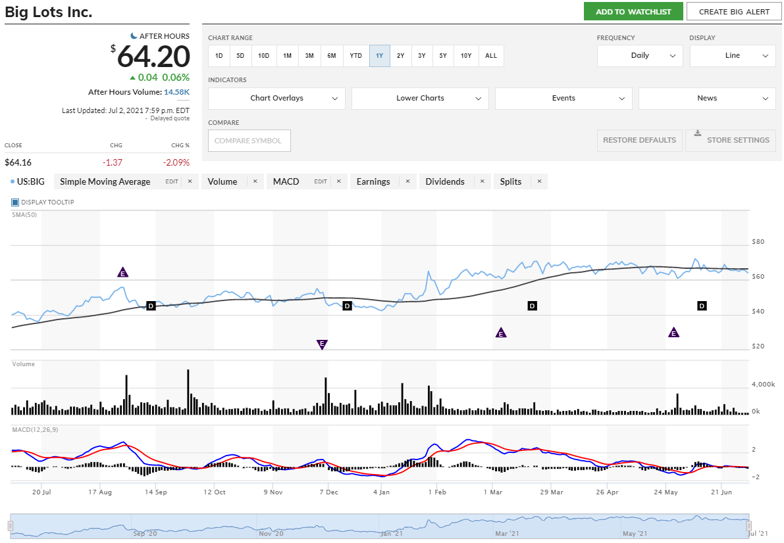

֎ Corresponding email:

